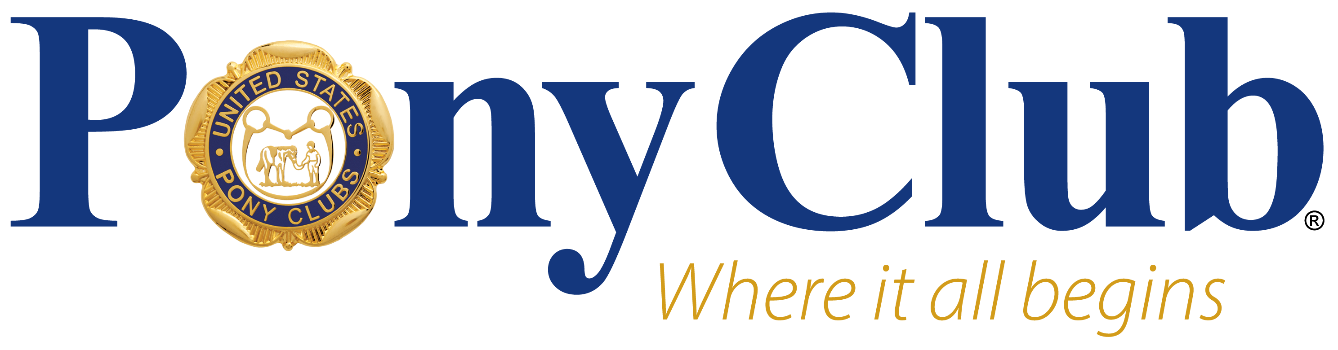
THE UNITED STATES PONY CLUBS, INC. PRESS RELEASE
FOR IMMEDIATE RELEASE – PHOTOS AVAILABLE UPON REQUEST
Press Contact: Samantha Smith, communications@ponyclub.org
Pony Club: ponyclub.org | (859) 254-7669

2023 Carolina Region Quiz Rally

The Carolina Region's Quiz Rally was held Saturday, February 11, 2023. It was hosted by the Cardinal II Pony Club and held at Palisades Episcopal School in Charlotte, NC. This is an excellent venue for Quiz Rally. The school offers an equestrian program and has a barn which is perfect for the barn phase. Many thanks to April Wilde, rally organizer and Jenny Kaeppler, rally secretary for all of their hard work to make this rally such a wonderful experience for all involved. Thanks to ALL of those that volunteered for without you this would not have been possible. A special thanks for Emily Frye for making arrangements for us to use this fabulous facility.
For the record, there were three divisions that competed. Division I consisted of 6 teams of Novice D up to 11 years old. First place-Cardinal II, Second place-Aiken County, Third place-Greenville Foothills, Fourth place-a scramble team of Eno Triangle and Greenville Foothills, Fifth place-Yadkin Valley Hounds, and Sixth place-Radway Eventing. Division II consisted of 5 team of Junior D 12-17 years old. First place-a scramble team of Greenville Foothills, River Valley and Yadkin Valley Hounds, Second place-Sandhills, Third place-a scramble team of Aiken County and Cardinal II, Fourth place-a scramble team of Cardinal II, Palmetto and River Valley, and Fifth place-a scramble team of Aiken County, Lowcountry and Radway Eventing. Division III consisted of two teams of Junior C 12-17 years old. First place-a scramble team of Aiken County, Sandhills and Yadkin Valley Hounds and Second place-a scramble team of Eno Triangle and Greenville Foothills. Congratulations to ALL!

About The United States Pony Clubs, Inc. — The United States Pony Clubs, Inc. (USPC or Pony Club) is a 501(c)(3) nonprofit educational organization that builds the foundation of teamwork and sportsmanship through riding, mounted sports, care of horses and ponies, while developing and enhancing leadership, confidence, responsibility, and a sense of community in its youth and adult members. USPC is proud to offer instruction and competitive opportunities in more than 10 different disciplines through hundreds of clubs and centers across the United States. USPC’s educational standards continue to be instrumental in curriculum development for schools, universities, equestrian professionals, and organizations across the United States. Many of the nation’s top equestrians, including Olympic team members, as well as successful business professionals and leaders in a variety of fields, have roots in Pony Club.

